Michael English

Statistical Analysis

Springboard

For the statistics/graph component, a jitter/scatter plot was coded on two databases – BTS (Database of Flights) and Atlanta_Routes (Flight Routes, BTS). For the BTS database, this plot was drawn up with values on the x-axis set at the dates of each day in March (Time variable) with the y values. The colors were separated by listing the top six major cities with highest aggregate flights from Atlanta in March 2019, found on the Atlanta_Routes database.

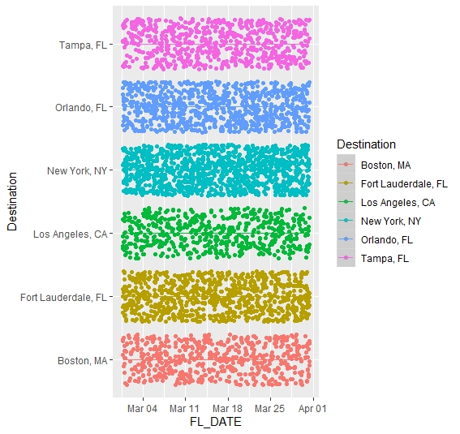

A major point of note is that each point is indicative of a separate plane and instance of flight – each tail number in the BTS database is represented on the chart, displaying the density of flights per week for to each of the six major cities.

The next chart is a histogram based on the data from the Atlanta_Routes dataset:

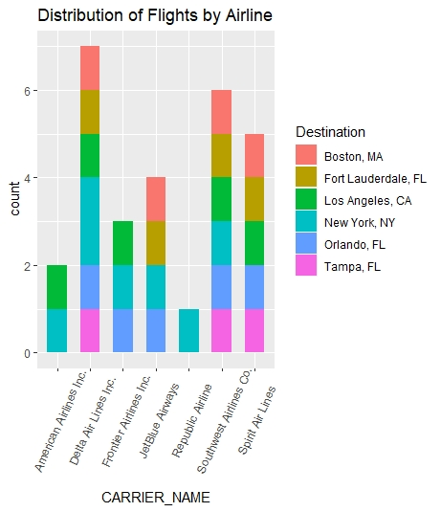

In this chart, there is an adjustment that needs to be made on wrapping the terms on the x variables for the histogram. This chart shows the distribution of flights by airline that are leaving enplaning from Atlanta, GA. Because of the density of the flight data and number of airlines, the next adjustment on values will be to refine the values of the dataset to only include data associated with enplaned flights from Delta Air Lines and Southwest Airlines. Atlanta is the home hub for both airlines and they move most of their flights to and from the Atlanta Airport. Studying those two airlines solely will still provide detailed and well-approximated data on passenger activity and population at a given time, despite the removal of other airlines.